# GO Comet

# Description

Requesting data from GO Comet API regular intervals for port congestion and mapping it companies nearby port.

# Flowchart

# 5.2. DataMyne Crawler

# Description

Downloads the data for partner network from DataMyne website and stores into database.

# Flowchart

# PO data Partner Network

# Description

Reading PO data from ADLS and Creating partner network through it and storing in it database .

# Flowchart

# CSI Market financial data

# Description

Reading data from database for company names and scraping financial details from CSI Market for companies.

# Flowchart

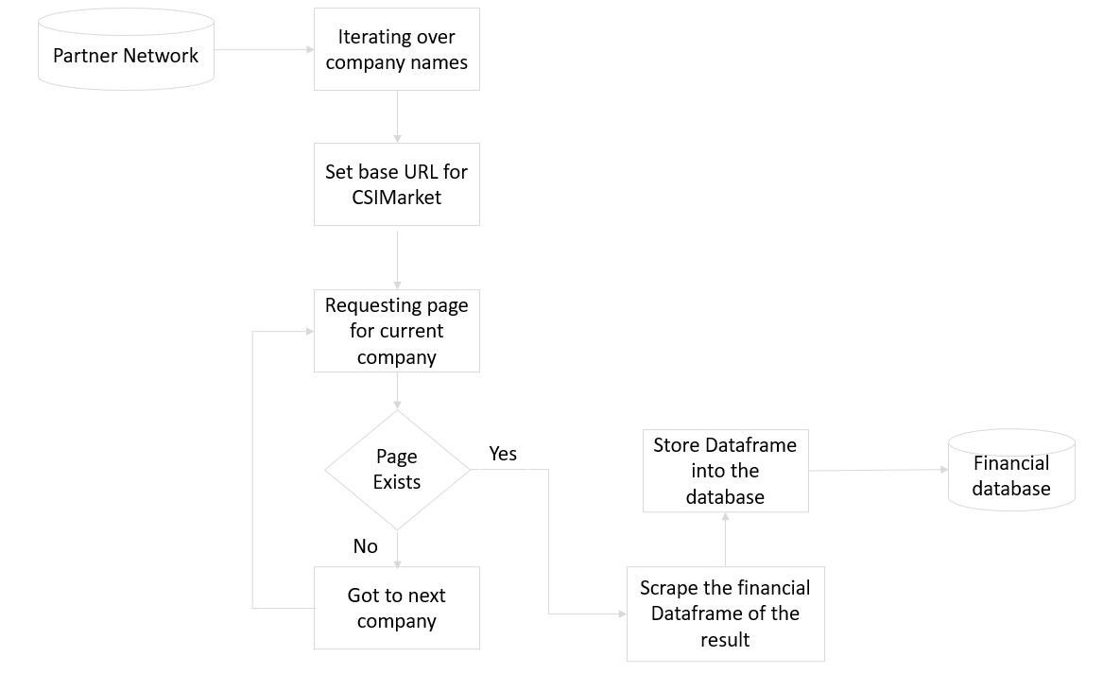

# Backend (Low Level Design)

Following diagram indicates the list of backend modules to be developed

## **Data Model**

## **First layer**

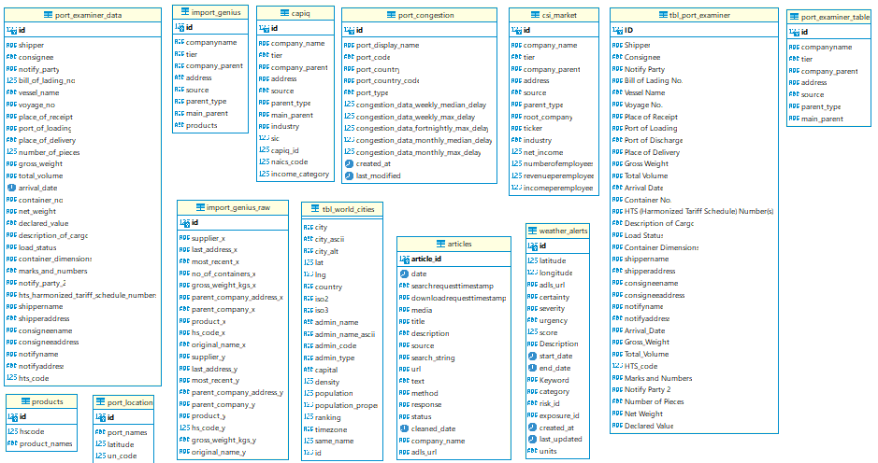

## **Second layer**

## **Third layer**

